**Wetwang Parish Council**

Wetwang Community Hall, Southfield Well Balk, Wetwang YO25 9XX

www.wetwangparishcouncil.org.uk

[wetwangpc@gmail.com](mailto:wetwangpc@gmail.com)

30th December 2024

To: All members of the Parish Council, Ward Councillors, and local press

Dear Councillor,

You are hereby summoned to an Ordinary Meeting of Wetwang Parish Council to be held on **Monday 6th January 2025** commencing at **7.30pm** at the Community Hall, Southfield Road, Wetwang. YO25 9XX. To transact the business set out below.

Members of the public are welcome to attend and may address the Council during public participation.

Yours sincerely

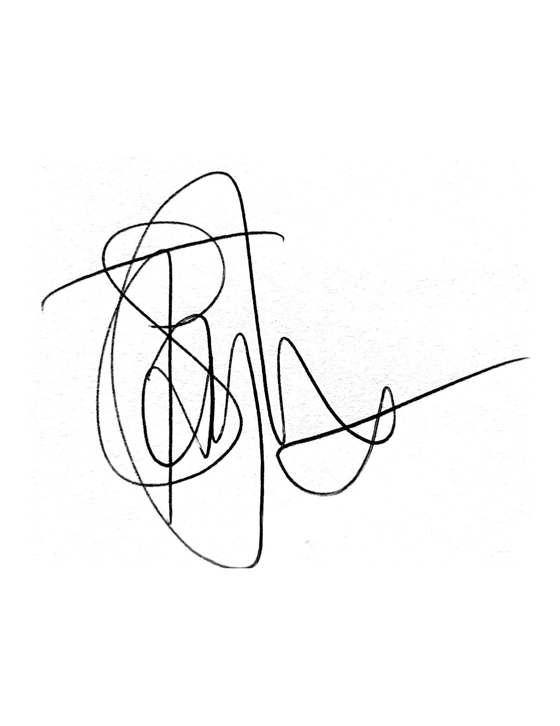

Clerk to the Parish Council

**Agenda**

**Ordinary Meeting**

1. **Notice of Meeting** – To confirm that notice has been given in accordance with: Schedule 12, Paragraph 10 of the Local Government Act 1972.
2. **Apologies** – To note any apologies for absence**.**

**Open Forum**

1. To allow members of the public / Councillors with pecuniary or non-pecuniary interest to speak within the Council meeting (maximum 15 minutes)
2. To decide on what action the Council wish to take on any items raised within the Open Forum

**Police**

To receive representation from Humberside police

1. **Declaration of Interest –** To record Declarations of Interest by any member of the Council in respect of the agenda items below. Members declaring interests should identify the agenda item and type of interest being declared. If the interest is prejudicial the member shall leave the room for the discussion and voting on that item. In accordance with The Localism Act 2011, The Relevant Authorities (Disclosable Pecuniary Interest) Regulations 2012.
2. **Correspondence Received –** To receive any correspondence not relating to the agenda.
   1. VE Day 80 – 8th May 2025
   2. Community Governance Review – the final recommendation is to reduce the number of Parish Councillors from eleven to nine, effective from May 2027.
3. **Matters Arising –** To receive an update from the Clerk on matters arising from the previous meeting and discuss any relevant actions required.
   1. Yorkshire Wolds Pulham Bus Service – request to serve Wetwang
   2. Yorkshire Wolds Area of Outstanding Natural Beauty consultation.
4. **Approval of Minutes –** To receive and sign the minutes of the Parish Council Meeting held on Monday 2nd December 2024 as a true and correct record.
5. **Reports from Committees & Representatives -** To receive a report and approve/record any action needed for the following:
   1. **Wetwang Community Hall**
   2. **Wetwang Primary School**
   3. **updates from other Community Groups / Sub Committees**
6. **Planning Applications** 
   1. To consider applications for Planning Permission upon which the Parish Council has been consulted:

|  |  |  |
| --- | --- | --- |
| **Proposal** | **Location** |  |
| Change of use of land and the siting of five glamping pods, new access, internal road and associated works | Land West Of Rocklands Farm Malton Road Wetwang East Riding Of Yorkshire YO25 9LS | <https://newplanningaccess.eastriding.gov.uk/newplanningaccess/PLAN/24/03645/PLF> |

* 1. To receive an update on previous applications consulted on:

|  |  |  |
| --- | --- | --- |
| **Proposal** | **Location** | **Decision** |
| None |  |  |

1. **Parish Council Facilities –** To receive a report from the clerk and approve/record any action needed for the following:
   1. **Allotments**
   2. **Burial Ground**
   3. **Playing Field (Station Hill)**
   4. **Community Park (Northfield Road)**
   5. **Bus Shelter (Main Street)**
   6. **Village Pond**
2. **Finance**
3. To sign the precept demand 2025/26 for submission to East Riding of Yorkshire Council
4. To sign the letter of engagement for internal audit services
5. To note pre-approved bank payments and debit card purchases

|  |  |  |  |
| --- | --- | --- | --- |
| Clerk | Salary | To note the increase in the clerk's hourly rate from £12.42 to £13.05. | Standing Order |
| HMRC | Tax | redacted | Direct Debit |
| Sovereign | Playpark inspection and maintenance | £17.99 | Direct Debit |
| Scribe | Accounts package | £12.00 | Standing Order |

1. To approve the schedule of accounts for payment:

|  |  |  |  |
| --- | --- | --- | --- |
| Nick Thurlow | Burial Ground fencing | TBC | BACs |

1. **Maintenance of the Village –** To discuss any maintenance issues in the Village.
2. **To receive items for the next Agenda –** To receive items to be placed on the following meeting’s agenda for discussion and/or resolution
3. **To confirm the date of the next Meeting –** Ordinary Council meeting: Monday 3rd February 2025 (7.30pm).

**Future meeting dates**: 3rd March 2025, 7th April 2025, 12th May 2025 – Annual Council Meeting (7pm), 2nd June 2025, 7th July 2025, 1st September 2025, 6th October 2025, 3rd November 2025, 1st December 2025.