Wetwang Parish Council
Wetwang Community Hall, Southfield Well Balk, Wetwang YO25 9XX
www.wetwangparishcouncil.org.uk
clerk@wetwangparishcouncil.org.uk

25th February 2026

To: All members of the Parish Council, Ward Councillors, and local press

Dear Councillor,
You are hereby summoned to an Ordinary Meeting of Wetwang Parish Council to be held on Monday 2nd March 2026 commencing at 7.30pm at the Community Hall, Southfield Road, Wetwang. YO25 9XX. To transact the business set out below.
Members of the public are welcome to attend and may address the Council during public participation.
Yours sincerely
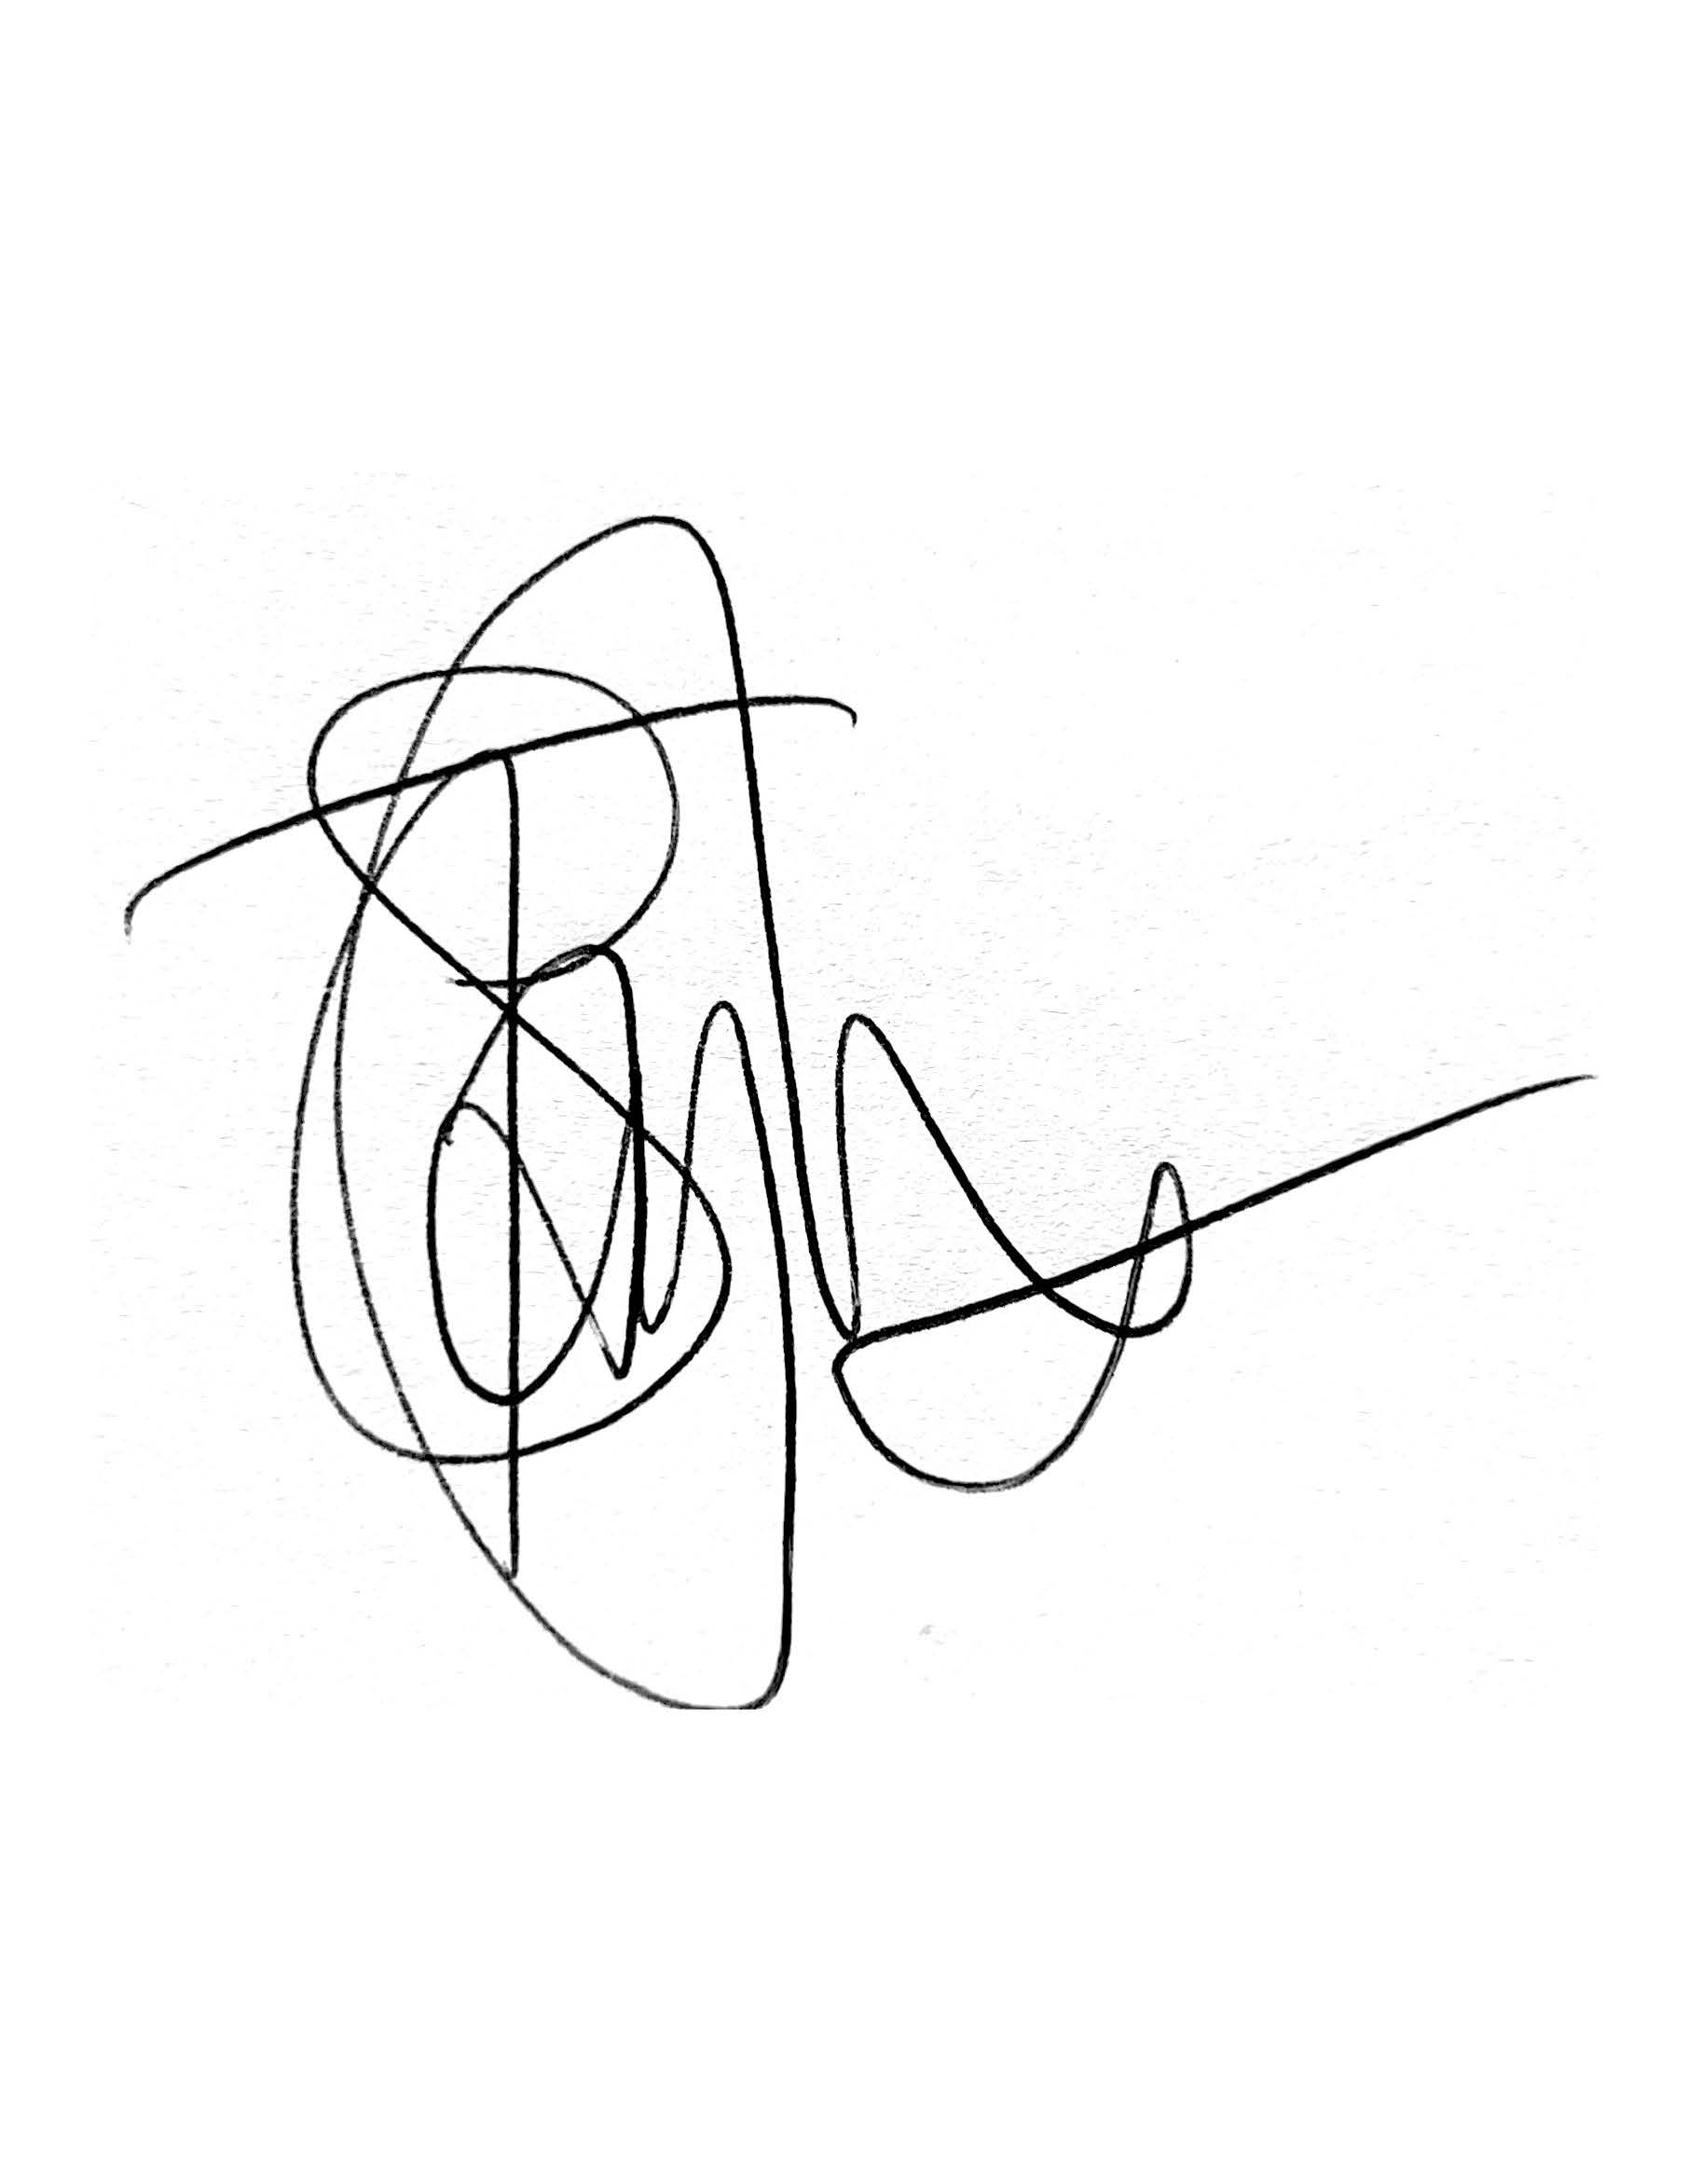
Clerk to the Parish Council

Agenda
Ordinary Meeting
- Notice of Meeting – To confirm that notice has been given in accordance with: Schedule 12, Paragraph 10 of the Local Government Act 1972.
- Apologies – To note any apologies for absence.
Open Forum
- To allow members of the public / Councillors with pecuniary or non-pecuniary interest to speak within the Council meeting (maximum 15 minutes)
- To decide on what action the Council wish to take on any items raised within the Open Forum
Police
To receive representation from Humberside police
- Declaration of Interest – To record Declarations of Interest by any member of the Council in respect of the agenda items below. Members declaring interests should identify the agenda item and type of interest being declared. If the interest is prejudicial the member shall leave the room for the discussion and voting on that item. In accordance with The Localism Act 2011, The Relevant Authorities (Disclosable Pecuniary Interest) Regulations 2012.

- Correspondence Received – To receive any correspondence not relating to the agenda.
  - ERYC Consultation - Proposed dedication of public footpath

- Matters Arising – To receive an update from the Clerk on matters arising from the previous meeting and discuss any relevant actions required.
  - Road Safety Measures grant scheme

- Approval of Minutes – To receive and sign the minutes of the Parish Council Meeting held on Monday 2nd February 2026 as a true and correct record.

- Reports from Committees & Representatives - To receive a report and approve/record any action needed for the following:
  - Wetwang Community Hall
  - Wetwang Primary School
  - St Nicholas Church
  - updates from other Community Groups / Sub Committees

- Planning Applications
  - To consider applications for Planning Permission upon which the Parish Council has been consulted:

Proposal | Location | Link
None.

  - To receive an update on previous applications consulted on:
Proposal | Location | Decision
Erection of single storey extension with flue and render to rear following part demolition of existing | 25 Pulham Lane Wetwang East Riding Of Yorkshire YO25 9XT  Ref. No: 25/03593/PLF | Pending Consideration

  - To receive an update on Gameslack Farm Community Liaison Group
  - To receive an update on Chariots Keep development

- Parish Council Facilities – To receive a report from the clerk and approve/record any action needed for the following:
  - Allotments
  - Burial Ground
  - Playing Field (Station Hill)
    - Grounds Maintenance fee increase request – to discuss the increase of the fee paid to £1700 per annum for maintenance of the playing field.
  - Community Park (Northfield Road)
  - Bus Shelter (Main Street)
  - Village Pond

- Finance

- To consider the grant applications received:
  - Wetwang Bowls Club
- To note pre-approved bank payments and debit card purchases
Clerk | Salary | Redacted | Standing Order
HMRC | Tax | Redacted | Direct Debit
Sovereign | Playpark inspection and maintenance | £17.99 | Direct Debit
Scribe | Accounts package | £14.40 | Standing Order
- To approve the schedule of accounts for payment:
None

- Maintenance of the Village – To discuss any maintenance issues in the Village.

- To receive items for the next Agenda – To receive items to be placed on the following meeting’s agenda for discussion and/or resolution

- To confirm the date of the next Meeting – 13th April 2026 – Ordinary Council Meeting (7.30pm).
Future meeting dates: 11th May 2026, 1st June 2026, 6th July 2026, 7th September 2026, 5th October 2026, 2nd November 2026, 7th December 2026.

